Installing Thonny and Python at the same time:

Goto Thonny URL

<https://thonny.org/>

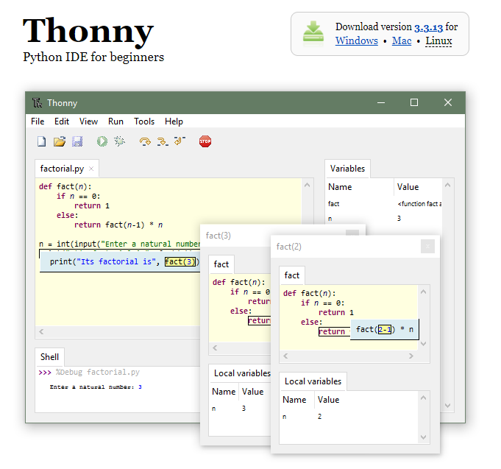

Click on Windows (if you are installing on Windows PC)

Python will be installed as well

